CERTIFIED AMENDMENT TO THE CONDOMINIUM DOCUMENTS

I, Dennis Schueler, the duly elected and qualified secretary of the Board of Directors for Eagle's Nest on Marco Beach, do hereby certify that at a Board of Directors meeting on February 25, 2014; the following amendment was adopted with proper notice given to Eagle's Nest owners.

MOTION was made by Mr. Lang and seconded by Mr. Cockerell to Preserve the Declaration of Covenants, Conditions and Restrictions for Flexible Use Ownership in order to avoid extinguishment by the Marketable Record Title Act before the 30'h anniversary of recording which is on Thursday, August 18, 2016. Mr. Cockerell voted aye, Mr. Doherty voted aye, Mr. Lang voted aye, Mr. Shelby voted aye and Mr. Schueler voted aye. Motion carried unanimously,

EXECUTED at Marco Island, Florida, this S day of March, 2014.

Signed, sealed and delivered in the presence of

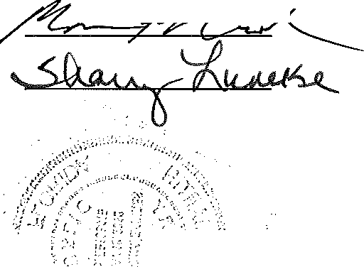Mona Fohlbrook

Sharry Luneke

INSTR 4954967 OR 5016 PG 2089
RECORDED 3/13/2014 9:01AM PAGES 2
DWIGHT E. BROCK, CLERK OF THE CIRCUIT COURT
COLLIER COUNTY FLORIDA REC$18.50

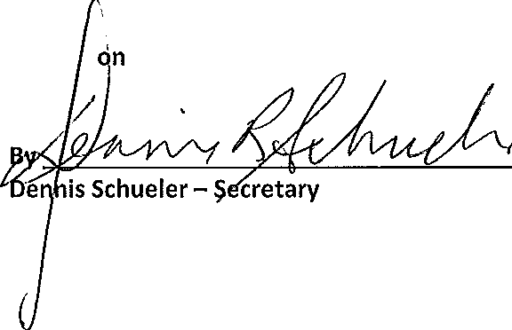Eagle's Nest
Corporation
Marco Beach a Florida not-for-profit

_.,.,.
..

J f.:' '

s'fP.koF FlbRI(!A' }

COUNTY OF COLLIER }

The foregoing instrument was acknowledged before me this '5 of March, 2014 by Dennis Schueler, as Secretary of the Eagle's Nest on Marco Beach Condominium Association, Inc., a Florida not-for­
profit Corporation, on behalf of the Corporation, who is personally known to me and did take an oath.

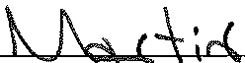

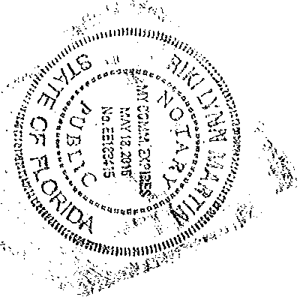Riki Lynn Martin
' • f

Commission No. EE188415
Commission Expires May 18, 2016

NOTICE OF
BOARD OF DIRECTORS MEETING

Call to Order
AGENDA

Eagle's Nest on Marco Beach Condominium
Association, Inc.

Tuesday, February 25, 2014
1:00 p.m. (Eastern Time)
at

Auditor's Financial Update Marketable Record Title Act Adjournment

410 South Collier Blvd. Marco Island, FL 34145

NOTICE OF ANNUAL OWNERS MEETING

Call to Order
AGENDA

Eagle's Nest on Marco Beach Condominium
Association, Inc.

Tuesday, February 25, 2014
2:00p.m. (Eastern Time)
at

410 South Collier Blvd. Marco Island, FL 34145

CURRENT BOARD OF DIRECTORS

Mr. Tom Cockerell- President

Mr. Pat Doherty - V. President

Mr. Dennis Schueler- Sec./Treas. Mr. Charlie Shelby- Director
Mr. Lucky Lang - Director

Determination of Quorum

Approval of 2013 Annual Meeting Minutes

Manager's Report

Resale Report

Board President's Report Questions and Answers Board of Director's Election Adjournment

